The Animal Lighthouse by Anthony Burt
School & Festival Events
About the book
"This swashbuckling, joyous adventure left me BEAMING with delight!" Vashti Hardy
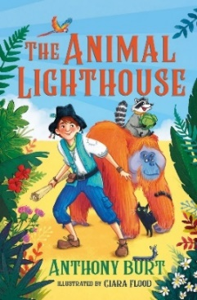
An exciting piratical adventure about Jim, a boy washed up on a hidden island as a baby and cared for by a wonderful family of animals. Life as a lighthouse keeper is full of fun and adventure until one day a pirate ship is spotted, bringing with it unwanted, dangerous answers to Jim's past and who his real family is. A piratical adventure for fans of Johnny Duddle and Vashti Hardy.

The Animal Lighthouse by Anthony Burt | 9781913101527 | £6.99 | Paperback | May 2022 | Guppy Books
Explore the Animal Lighthouse
About the events
Join author Anthony Burt for a swashbuckling introduction to his new novel The Animal Lighthouse, a reading and a PowerPoint talk about how he became a children’s author. There are three different workshops to choose from focused around creative writing and STEM learning for ages 7 to 12:

Animal Crackers – we’ll learn everything there is to know about orangutans, why they are endangered, how they move, and how they’re so smart. Anthony will lead an interactive world-building and character creating activity, using props, puppets, performance and draw-a-longs to show children how to make their own, realistic and brilliant animal characters for stories!
Lighthouse Gadgets – heading inside the lighthouse, we’ll use Anthony’s giant “broken” circuit board, light prisms and objects to discover the history of lighthouses, how they work, who runs them, and take a look at all the cool technical gadget wizardry that makes them the amazing ships’ saviours of the seas. Then we’ll invent the insides of our own gadget-laden lighthouses for a story!
Maps & Mirages – Anthony will use objects, role play and STEM topics to show how a “Fata Morgana” mirage works in real-life and how the special lighthouse beam three-and-a-half in The Animal Lighthouse creates this optical illusion to keep the island hidden. We’ll do world-building and map-drawing so children can create their own island setting for their story!

- Workshops tailored for age / suitable for class size Years 3-6 and assemblies / sessions include a 7-page educational print and teacher resource on mirages, orangutans and lighthouses
- Event is 1 hour including time for Q&A / Extra time needed for book sales and signing
- In person – £175 half day (2 sessions) / £300 full day (4 sessions) + travel expenses / Digital – 1 hr session – £75
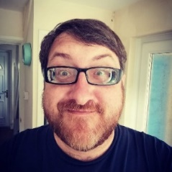
About Anthony Burt
Anthony has worked in primary, secondary and adult education for over twenty years, and run inspiring community youth work, art, film and TV projects for children with SEND. He’s a qualified teacher, book festival host, and loyal butler to his cat, Watson. Anthony has been writing since he was five-years-old, and has written for CiTV, Doctor Who Adventures magazine, Nickelodeon, and Disney.

